Discovering Jean-Philippe Nuel's spaces

Hotel Villa Koegui | Restaurant Le Carré
Bayonne, France

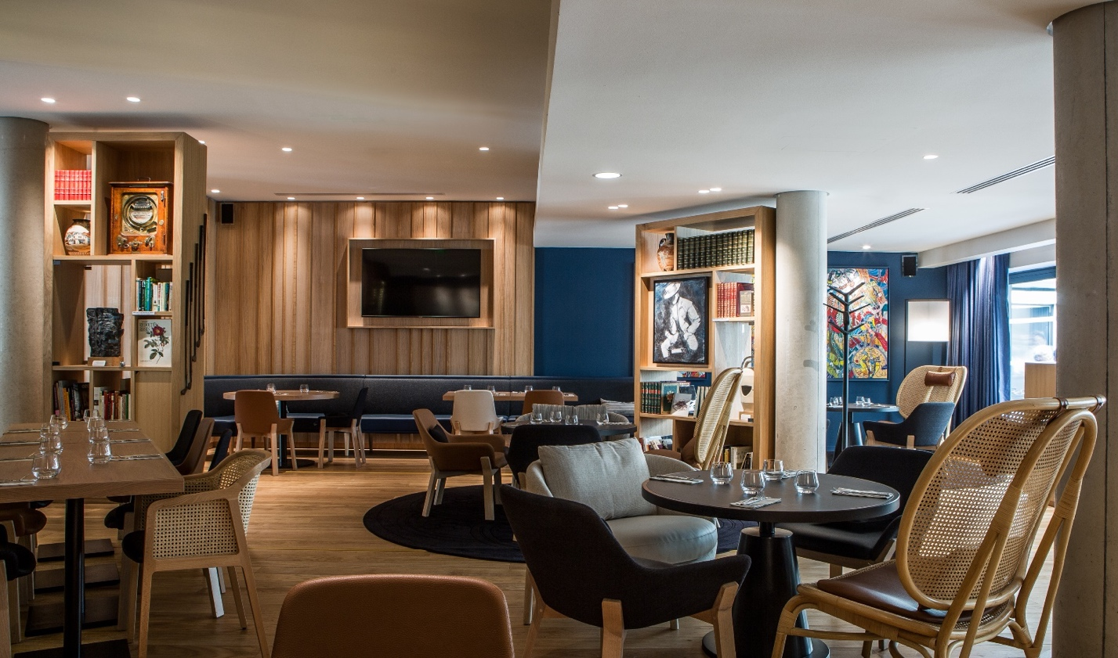

Bayonne, the thousand-year-old city located in the French Basque country, unfolds joyfully in a maze of colorful streets and alleys. There, architect and interior designer Jean-Philippe Nuel and Biarritz architect Bernard Signoret have given shape to the Hotel Villa Koegui and the restaurant Le Carré, where innovation and the future intersect with history and heritage.

"A contemporary hotel must voluntarily be part of its local environment; a guest may discover it as a stranger but, on arriving, they are entirely immersed in the surrounding city," explains Jean-Philippe Nuel. "The Villa Koegui and the Carré bear witness to this encounter between modernity and an open path to the past.” This 43-room hotel finds its place in the heart of historic Bayonne.

The contemporary facade echoes the city's half-timbered buildings, which themselves bear witness to the architectural tradition of the shipbuilding industry, "a facade that is deliberately fragmented to blend with its dense surroundings," adds Jean-Philippe Nuel.

Everything in the design of Villa Koegui’s interiors suggests an invitation to the Basque Country’s art of living and history. Thus, the main inspiration was the tradition of the Peñas, which brings people together around shared passions.

"The ambition was to give the Peñas a contemporary interpretation, accessible to all through the cherished themes of Basque culture: music, gastronomy, art, and sports," explains Jean-Philippe Nuel. The hotel's common areas and rooms are decorated with a collection of more than 600 works of art -- engravings, traditional paintings from the 19th century and more contemporary works -- whose common denominator is the Basque Country.

The artistic appeal is completed by the first-floor bookshelves filled with a selection of novels, poetry, and photographic works, each one selected by Guy Néplaz, the hotel’s owner, a publisher, and a seller of vintage books. The personalized touch ingrains the hotel with a welcoming, familiar, and human atmosphere.

Beyond serving as a passageway for guests to the city of Bayonne, Villa Koegui offers links to the regional lifestyle and the possibility of experiencing the festive character of the Peñas, closely linked to Bayonne’s festivals. Thus, the bar, placed in the center of the space, is crowned with a multicolored garland from which emanates the friendly, joyful, and generous Bayonne spirit.

Villa Koegui's restaurant, Le Carré, reflects its past as the Carré Bonnat, once the gathering place of the Basque artistic avant-garde. Visitors and residents of Bayonne can enjoy Le Carré throughout the day for a meal, a drink and some pintxos (a Basque specialty made of a slice of bread topped with a culinary creation). Here, the hotel function recedes into the background to make room for the nourishing Basque gastronomic culture.

The rooms another facet of Bayonne's culture to be explored through the display of works by Bonnat and Helleu. Léon Bonnat—a painter and engraver—was born in Bayonne in 1833. He is remembered for his portrait gallery featuring some of France’s greatest figures of the late 19th century: Pasteur, Hugo, Gambetta, and Alexandre Dumas fils. Paul Helleu, a painter of the same period, is also very present in the Bayonne Museum of Fine Arts, found just a few steps from the hotel.

An accompanying explanation of each reproduction further adds to the hotel’s unique identity. The full-scale impression of the characters creates a specific relationship, offering visitors an opportunity to enter an intimate dialogue with the paintings, whose characters seem ready to emerge from the walls for a surprising encounter, providing another facet of the journey into history proposed by Villa Koegui.

Finally, the works of local artisans also enters into this cultural mooring with the detailing of the Bayonnaise-style parquet floor and the Bayadère in the bathroom tiles giving meaning to the decorative choice.

PROJECT INFORMATION:

Status : Opened
Floors : 5
Rooms : 43
Services : Restaurant / bar “Le Carré” with back patio, fitness, and sauna
Size : 1780 m²
Client : SCI VGI BASTIAT – Guy Néplaz
Architects : Bernard Signoret – Studio Jean Philippe Nuel co-architects
Project Manager for Studio Jean-Philippe Nuel: Monia Belair Dumond

KEY WORDS:

Heritage : historical district - half-timbering - shipbuilding - Bayonne - friendly - pinxtos - craftsmanship
Architecture : contemporary facade - split
Traditions : Basque Country - Peñas - Bayonne Festival - traditional songs - art of living - gastronomy - warm - joyful - generous - sharing - sport (rugby / rowing /pelota / chistera / Basque strength)
Art: works of art - painting - literature - libraries - crafts - pottery - makila
Materials : bayonnaise parquet - oak - granito - leather - bayadère - pottery

-----------------------------

PRACTICAL INFORMATION :

Address : VILLA KOEGUI BAYONNE – 7 rue Frédéric Bastiat – 64100 BAYONNE
Tel : 05 59 85 85 98
Mail : contact@villakoegui-bayonne.fr
Site : https://hotel-villakoegui-bayonne.fr/
Instragram : instagram.com/hotelvillakoeguibayonne
Chargé de communication pour KOEGUI BAYONNE : Aurore DUCOS
communication@villakoegui.fr – communication@groupe-koegui.fr

-----------------------------

MEDA CONTACT | LE STUDIO JEAN-PHILIPPE NUEL :
JC AGID | jcagid@thirtyseveneast.com | + 1 9173498361

LE STUDIO JEAN-PHILIPPE NUEL :

Based in Paris and New York, Studio Jean-Philippe Nuel is an international signature in luxury interior design. The design expertise of Studio Jean-Philippe Nuel is found in hotel brands, private residences, concept stores, corporate headquarters, and cruise ships. It employs 30 people.
Among the Studio’s most iconic projects are the Grand Hôtel-Dieu in Lyon and the Hôtel-Dieu in Marseille (Intercontinental), La Clef Champs-Elysées (Ascott), the Molitor Hotel, Les Cures Marines in Trouville (MGallery), Le Cinq Codet in Paris and the Villa Borghese hotel in Rome (Sofitel). Trained as an architect, Jean-Philippe Nuel has also created architectural projects, alone or in collaboration, for hotels, private homes, wine cellars, and other remarkable projects.
The Studio Jean-Philippe Nuel also performs in the field of product design through collaboration with major houses such as Ligne Roset, Pierre Frey, Colombo Design or Saint Luc. He thus touches on all aspects of a project, from architecture to design and interior decoration, seeking strength and coherence for each of his creations.
Studio Jean-Philippe Nuel has a strong international presence and has opened a New York office headed by designer Sandy Stevens-Despres.

STUDIO JEAN-PHILIPPE NUEL - FRANCE  Architecture d’intérieur & Design  9 boulevard de la Marne  94130 Nogent sur Marne  T +33 (0) 1 45 14 12 10  jpn@jeanphilippenuel.com | STUDIO JEAN-PHILIPPE NUEL – NORTH AMERICA  Sandy Stevens-Despres  Adresse 1204 Broadway, floor 4  New York, New York 10010  T + 1 917 903 4442  Sandy@jeanphilippenuel.com
www.jeanphilippenuel.com // Linkedin // Facebook @studiojeanphilippenuel // Instagram @jean_philippe_nuel

LA MARQUE :
A great traveler, publisher and literature enthusiast, Guy Néplaz opened a prestigious bookstore in Bayonne in 2006 under the enigmatic name KOEGUI (a contraction of his own first name and that of his wife Ildiko).
In 2012, noting that "Writers of the Sea" who came to visit him, desert the city in the evening for lack of finding an honorable hotel, he takes, in less than a week, the decision to build one. It will be the Hotel **** Villa KOEGUI.
There was a plot of land for sale in the museum district, a stone's throw from the Basque Museum, at the confluence of the Nive and Adour rivers, two 600 m2 plots of land all in length, a former garage and a contemporary art gallery formerly managed by the Bonnat-Helleu Museum and linked to it: the Carré Bonnat. From the outset, things were clear: there was no question of making a neo-Basque pastiche, the hotel would be resolutely modern without denying its origins. To carry out the project, Guy Néplaz surrounded himself with men of talent and experience: a Gascon architect, Bernard Signoret, and a Parisian architect, Jean-Philippe Nuel, a specialist in luxury hotels, who oversaw all the decoration and interior architecture.
The project took seven years to complete because of the many obstacles that accumulated: legal disputes, the requirements of Bâtiments de France, difficult terrain, construction interrupted by excavations, dramatic flooding a few weeks before the opening, and finally... confinement!
But Guy Néplaz and his faithful team believe in it, hold on against all odds and finally open the Hotel **** Villa KOEGUI Bayonne in June 2020.

